Eugene Ngo

1965514

EE 271 Fall 2022

Lab 2 Report

**Screenshots:**

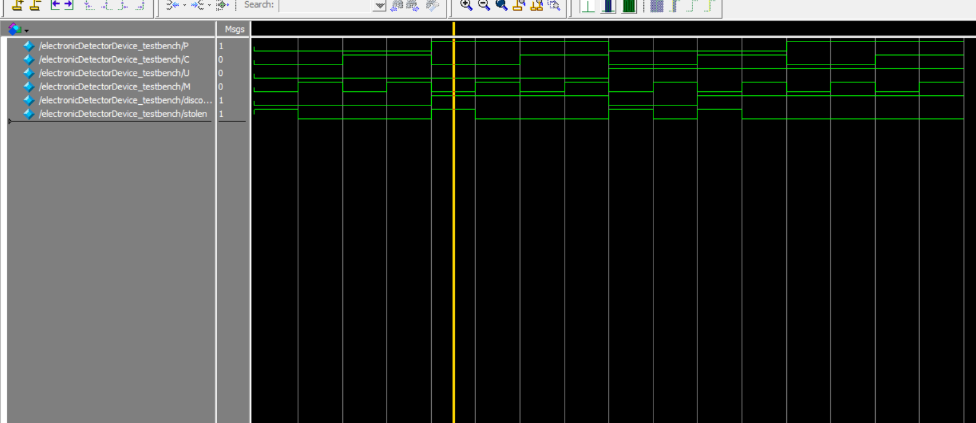

*Figure 1*

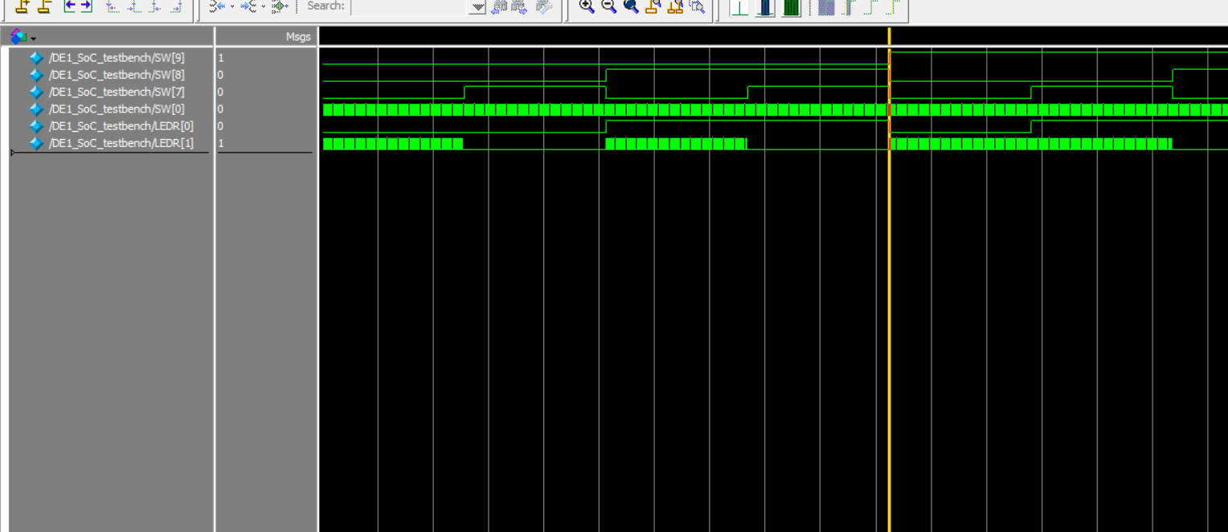

*Figure 2a*

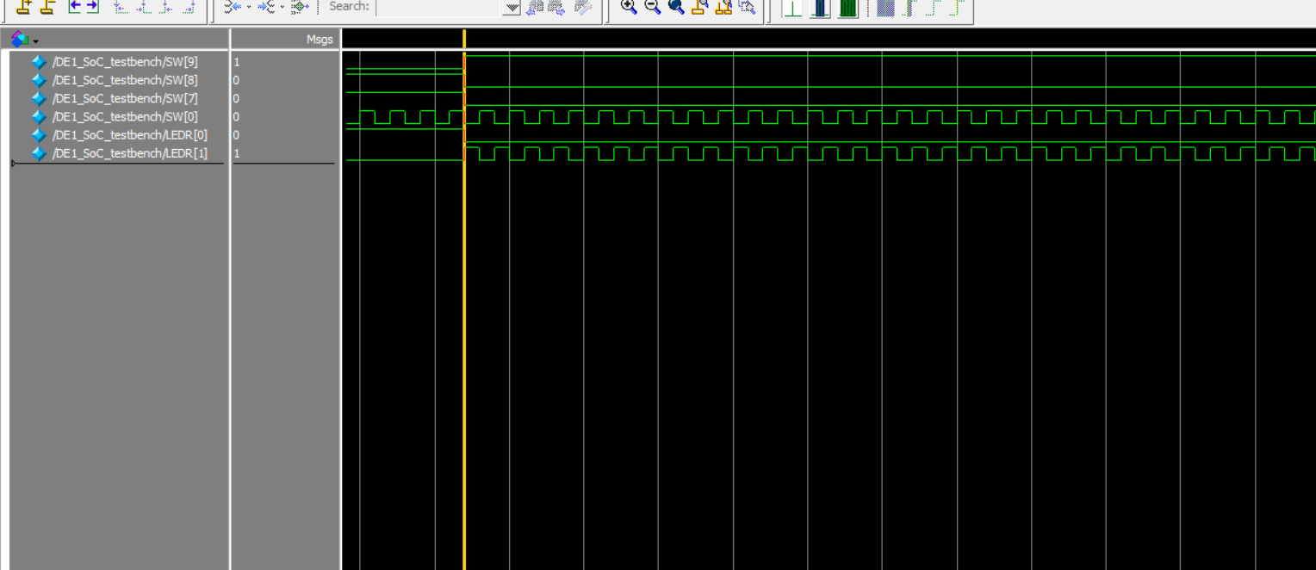

*Figure 2b*

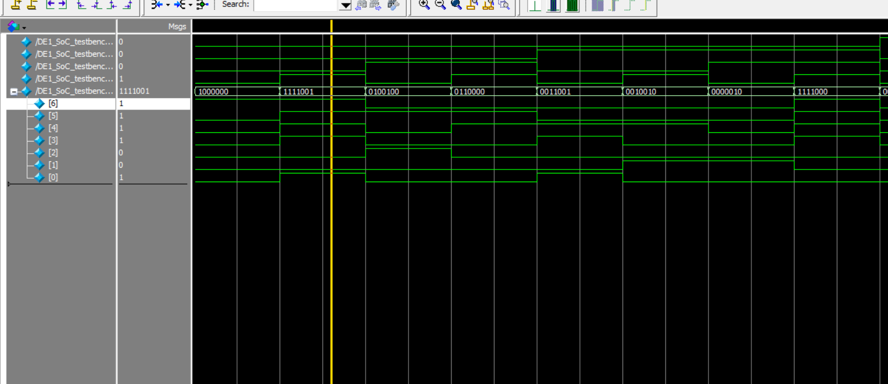

*Figure 3*

**Report:**

Before I began this lab, I took the given “Item Name – UPC code – Discounted – Expensive” table and created a truth table. From that truth table, I made k-maps which allowed me to find the simplest Boolean equation to find if an item was discounted, expensive, and/or stolen. This helped with the first part of the lab, the electronic detector device, as I used those Boolean equations in my logic. Attached is an image of this work.

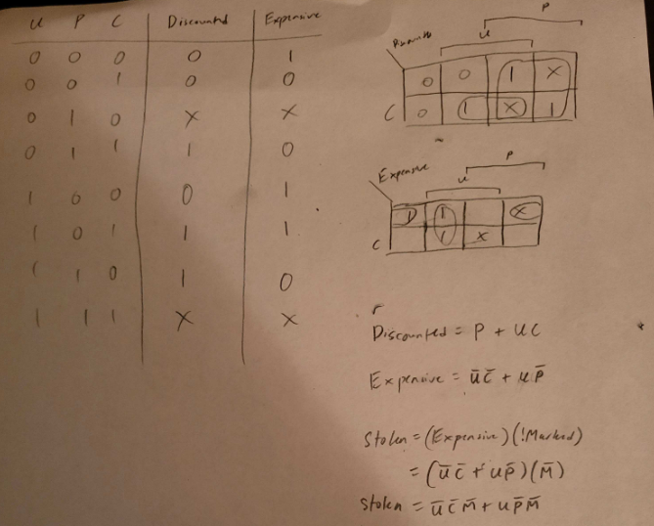

For the first part of the lab, I programmed the electronic detector device which using a UPC code would be able to identify the item and whether there is a discount on that item, as well as if the item is expensive or not. If the item is expensive, then when it is sold, it will be marked. If the electronic detector device does not detect a mark on an expensive item then that item will be marked stolen. Figure 1 shows the modelsim simulation of the electronic detector device.

Then after getting the electronic detector device working in simulations, I moved it onto the FPGA board by coding the DE1_SoC. Figure 2a shows the simulation of the DE1_SoC. Figure 2b depicts one of the cases. As seen in the screenshot, the UPC code is 100 because switch 9 is mapped to U, switch 8 to P, and switch 7 to C, while switch 0 is mapped to the mark. This UPC code is the Business Suit which is not discounted and is expensive. The discount is mapped to LED0 and stolen is mapped to LED1. As seen in the screenshot, in this case, there is no mark. So the outputs appropriately show LED0 as off since the item is not discounted and LED1 as on since the item is stolen (expensive and has no mark).

Moving onto the second part of the lab, Figure 3 shows the 7seg HEX display being used. HEX0 is the output and displays the number associated with the inputted UPC code.

**Overview:**

Overall, the lab took a lot longer than expected. I also did the extra credit portion where the item name is displayed on the LEDs. This can be seen in the demonstration video submitted along with this report, but I will also describe it here. The final product delivered what the spec described and wanted. When the UPC code and mark was inputted, the appropriate LEDs for discount and stolen lit up and the HEX display would tell the user what item was inputted.